Real-Time Crowd Dynamics Analysis for
Preemptive Stampede Prediction using
ConvLSTM-Based Video Prediction

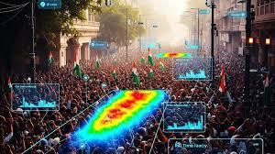

Real-Time Crowd Dynamics Analysis for
Preemptive Stampede Prediction using
ConvLSTM-Based Video Prediction
Software Requirements Specification

Version 1.1

Real-Time Crowd Dynamics Analysis for  Preemptive Stampede Prediction using  ConvLSTM-Based Video Prediction | Version : 1.1
Software Requirements Specification | Date : Janurary 20,2026
Revision History
Date | Version | Description | Author
24/Dec/2025 | 1.0 | Software Requirements Specification Document Initial Release. | Kamepalli Koushik
31/Dec/2025 | 1.1 | Software Requirements Specification Document Release 1.1. | Voota Koushik

Real-Time Crowd Dynamics Analysis for  Preemptive Stampede Prediction using  ConvLSTM-Based Video Prediction | Version : 1.1
Software Requirements Specification | Date : Janurary 20,2026

Table of Contents
- Introduction 4
  - Purpose 4
  - Scope 4
  - Definitions, Acronyms and Abbreviations 5
  - References 5
  - Overview 5
- Overall Description 6
- Specific Requirements 7
  - Functionality 8
 | 3.1.1 Video Input | 8  8  8  8
 | - Video Pre Processing  - Temporal sequence construction | 8  8  8  8
 | - Spatio Temporal modelling and prediction | 8  8  8  8
 | 3.1.5Anomoly detection and scoring  3.1.6 Alerts | 8
3.2 | Usability | 8
3.3 | Reliability | 8
 | 3.3.1 Availability | 8
 | 3.3.2 Mean Time Between Failures (MTBF) | 8
 | 3.3.3 Mean Time to Repair (MTTR) | 9
 | 3.3.4 Accuracy | 9
 | 3.3.5 Maximum Bugs or Defect Rate | 9
 | 3.3.6 Access Reliability | 9
3.4 | Performance | 9
 | 3.4.1 Response Time | 9
 | 3.4.2 Throughput | 9
 | 3.4.3 Capacity | 9
 | 3.4.4 Resource Utilization | 9
3.5 | Supportability | 9
3.6 | Design Constraints | 9
3.7 | On-line User Documentation and Help System Requirements | 10
3.8 | Purchased Components | 10
3.9 | Interfaces | 11
 | 3.9.1 UML Diagrams | 11
 | 3.9.2 Hardware Interfaces | 16
 | 3.9.3 Software Interfaces | 16
 | 3.9.4 Communications Interfaces | 16

  - Licensing Requirements 21
  - Legal, Copyright, and Other Notices 21
  - Applicable Standards 21
4 Supporting Information 21

Real-Time Crowd Dynamics Analysis for  Preemptive Stampede Prediction using  ConvLSTM-Based Video Prediction | Version : 1.1
Software Requirements Specification | Date : Janurary 20,2026
Software Requirements Specification

Introduction

Crowd stampedes represent a serious public safety risk in densely populated environments such as religious gatherings, transportation hubs, stadiums, concerts, and large public events. In such scenarios, crowd behavior can shift rapidly due to panic, congestion, or sudden disturbances, often leaving very little time for human operators to react. Traditional surveillance systems are largely reactive in nature, focusing on visual monitoring or post-event analysis, and lack the capability to anticipate abnormal crowd behavior before it escalates into dangerous situations.

Recent advances in computer vision and deep learning have enabled predictive modeling of crowd dynamics directly from video data. Instead of relying on handcrafted motion features or explicit crowd density estimation, modern approaches learn spatio-temporal patterns of normal crowd behavior and detect deviations that may indicate abnormal or potentially hazardous conditions.

This project proposes a Real-Time Crowd Dynamics Analysis for Preemptive Stampede Prediction System based on video anomaly detection using future frame prediction. The system employs a Convolutional Encoder–ConvLSTM Decoder architecture to learn normal crowd motion patterns from surveillance video sequences. By predicting future video frames and measuring deviations between predicted and observed frames, the system identifies abnormal spatio-temporal behavior that may serve as an early indicator of stampede-like events. The approach follows a one-class learning paradigm, requiring only normal crowd data for training and eliminating the dependency on annotated abnormal samples. This enables robust, computationally efficient, and proactive crowd safety monitoring suitable for real-world surveillance deployments.

Purpose

The purpose of this Software Requirements Specification (SRS) document is to define the functional and non-functional requirements of the Real-Time Crowd Dynamics Analysis for Preemptive Stampede Prediction System. This document describes the system behavior, interfaces, operational constraints, and performance expectations based on the predictive video anomaly detection framework presented in the research work.

The SRS serves as a reference for system design, implementation, testing, and validation. It ensures that the developed system aligns with the intended objective of early detection of abnormal crowd dynamics using ConvLSTM-based future frame prediction while maintaining reliability, efficiency, and usability in surveillance environments.

Scope

This Software Requirements Specification captures the complete requirements of the Real-Time Crowd Dynamics Analysis System in a single document. The system is designed to operate on surveillance video streams and automatically analyze crowd behavior in real time to detect abnormal motion patterns that may precede stampede events.

The Real-Time Crowd Dynamics Analysis System provides the following features:
• Continuous acquisition and preprocessing of surveillance video streams
• Conversion of video frames to normalized grayscale representations

Real-Time Crowd Dynamics Analysis for  Preemptive Stampede Prediction using  ConvLSTM-Based Video Prediction | Version : 1.1
Software Requirements Specification | Date : Janurary 20,2026

• Construction of temporal frame sequences for spatio-temporal modeling
• Learning of normal crowd dynamics using a ConvLSTM-based encoder–decoder architecture
• Future frame prediction for modeling expected crowd behavior
• Detection of abnormal crowd behavior using prediction and reconstruction error analysis
• Temporal smoothing and score normalization for stable anomaly detection
• Generation of early warning alerts when abnormal crowd dynamics are detected

The success of the system is measured by its ability to reliably detect abnormal crowd behavior with high sensitivity and stable temporal performance, while minimizing false alarms and maintaining computational efficiency suitable for real-time deployment.

Definitions, Acronyms and Abbreviations

• Crowd Dynamics Analysis (CDA) – Analysis of collective movement patterns and behavior of crowds over time
• Video Anomaly Detection – Identification of abnormal events or behaviors in video sequences based on deviations from learned normal patterns
• ConvLSTM – Convolutional Long Short-Term Memory network that models spatial and temporal dependencies in video data
• Future Frame Prediction – A predictive learning approach where future video frames are estimated from past frames
• One-Class Learning – A learning paradigm where the model is trained only on normal data and anomalies are detected as deviations
• Reconstruction Error – Difference between predicted and observed video frames used as an anomaly score
• Stampede – Sudden, uncontrolled crowd movement caused by panic, congestion, or abnormal disturbances

References
The SRS document refers to the following sources:
Research literature on crowd dynamics and video anomaly detection
Studies on ConvLSTM-based future frame prediction models
Publicly available crowd surveillance datasets such as the Avenue dataset
IEEE guidelines for Software Requirements Specification documentation

Overview

This Software Requirements Specification document provides a structured description of the Real-Time Crowd Dynamics Analysis for Preemptive Stampede Prediction System.

Section 2 describes the overall system characteristics, operating environment, assumptions, and constraints.
Section 3 specifies the detailed functional and non-functional requirements of the system.
Section 4 contains supporting and supplementary information relevant to system development and deployment.

Real-Time Crowd Dynamics Analysis for  Preemptive Stampede Prediction using  ConvLSTM-Based Video Prediction | Version : 1.1
Software Requirements Specification | Date : Janurary 20,2026

Overall Description

The Real-Time Crowd Dynamics Analysis for Preemptive Stampede Prediction System is a standalone, video-based surveillance decision support system designed to enhance public safety in crowded environments. The system operates as an intelligent monitoring layer on top of existing surveillance infrastructure and does not directly intervene in crowd movement or control mechanisms.

The system continuously analyzes surveillance video streams to learn normal crowd behavior patterns and detect abnormal spatio-temporal dynamics that may indicate the early stages of stampede-like situations. It follows a prediction-based video anomaly detection approach, where future video frames are predicted using a ConvLSTM-based encoder–decoder architecture. Deviations between predicted and actual frames are interpreted as abnormal crowd behavior. When abnormal patterns persist beyond normal temporal fluctuations, the system generates alerts to notify crowd management authorities.

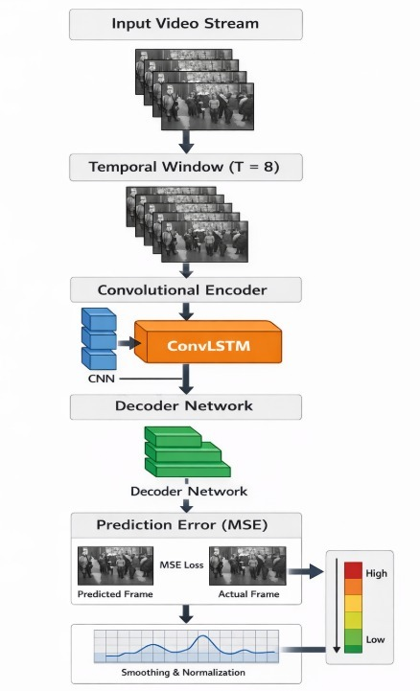
Figure 1Overview of the proposed system

Real-Time Crowd Dynamics Analysis for  Preemptive Stampede Prediction using  ConvLSTM-Based Video Prediction | Version : 1.1
Software Requirements Specification | Date : Janurary 20,2026

Product Functions:
The Real-Time Crowd Dynamics Analysis System provides the following core functions:
• Real-time acquisition and preprocessing of surveillance video streams
• Conversion of video frames to grayscale and normalized representations
• Construction of overlapping temporal frame sequences for modeling short-term crowd dynamics
• Learning of normal spatio-temporal crowd behavior using a ConvLSTM-based encoder–decoder network
• Prediction of future video frames based on historical frame sequences
• Computation of anomaly scores using prediction and reconstruction error
• Temporal smoothing and normalization of anomaly scores for stability
• Detection of abnormal crowd behavior indicating potential stampede risk
• Generation of early warning alerts upon detection of unsafe crowd dynamics
• Logging of anomaly scores and system events for monitoring and analysis

User Characteristics:

The system is intended to be used by the following categories of users:
• Crowd Management Authorities: No technical expertise required; interact with the system through alerts, warnings, and risk indicators
• Surveillance System Operators: Basic familiarity with video surveillance systems and monitoring interfaces
• Developers and Researchers: Knowledge of computer vision, deep learning, and video anomaly detection techniques

Constraints:

The system performance is subject to the following constraints:
• Quality of surveillance video, including resolution, frame rate, and noise levels
• Camera placement, viewing angle, and field of view
• Lighting conditions and environmental variability
• Available computational resources, particularly CPU and memory constraints for real-time processing

Assumptions and Dependencies:
The system operates under the following assumptions:
• Surveillance cameras are fixed and provide continuous video streams
• Crowd activity remains within the camera’s observable field of view
• The system is trained using normal crowd behavior data representative of the deployment environment
• Required software libraries, deep learning frameworks, and runtime environments are available and properly configured

Specific Requirements
This section describes in detail all the functional requirements.

Specific Requirements

This section describes in detail the functional and non-functional requirements of the Real-Time Crowd Dynamics Analysis for Preemptive Stampede Prediction System.

Real-Time Crowd Dynamics Analysis for  Preemptive Stampede Prediction using  ConvLSTM-Based Video Prediction | Version : 1.1
Software Requirements Specification | Date : Janurary 20,2026

3.1 Functionality

3.1.1 Video Input
The system shall accept video input from fixed surveillance cameras or prerecorded crowd surveillance videos.
The system shall support continuous frame-wise processing of video streams for real-time analysis.

3.1.2 Video Preprocessing
The system shall convert input video frames to grayscale format.
The system shall resize frames to a fixed resolution suitable for model inference.
The system shall normalize pixel values to ensure numerical stability during processing.

3.1.3 Temporal Sequence Construction
The system shall construct overlapping temporal windows of consecutive video frames.
The system shall use a fixed-length frame sequence as input for spatio-temporal modeling.
The system shall prepare the subsequent frame as the prediction target for future-frame estimation.

3.1.4 Spatio-Temporal Modeling and Prediction
The system shall employ a ConvLSTM-based encoder–decoder architecture to learn normal crowd dynamics.
The system shall predict future video frames based on past frame sequences.
The system shall operate under a one-class learning paradigm using only normal crowd behavior during training.

3.1.5 Anomaly Detection and Scoring
The system shall compute reconstruction or prediction error between predicted and observed frames.
The system shall convert prediction error into an anomaly score representing abnormal crowd behavior.
The system shall apply temporal smoothing and normalization to stabilize anomaly scores over time.

3.1.6 Alerts
The system shall generate alerts when anomaly scores exceed a predefined risk threshold.
The system shall prioritize high recall to ensure early detection of potentially dangerous crowd behavior.
The system shall log detected anomalies and alert events for later analysis.

3.2 Usability

• The system shall provide clear visual or textual alerts indicating abnormal crowd behavior
• No specialized technical training shall be required to interpret alerts
• The system shall present anomaly indicators in a simple and intuitive manner

3.3 Reliability

The system shall maintain high reliability due to the safety-critical nature of crowd monitoring applications.

3.3.1 Availability
The system shall remain operational during active surveillance periods with minimal downtime.

3.3.2 Mean Time Between Failures (MTBF)
The system shall be designed to minimize unexpected operational failures.

Real-Time Crowd Dynamics Analysis for  Preemptive Stampede Prediction using  ConvLSTM-Based Video Prediction | Version : 1.1
Software Requirements Specification | Date : Janurary 20,2026
3.3.3 Mean Time to Repair (MTTR)
In the event of failure, the system shall be restored within a reasonable time frame.

3.3.4 Accuracy
The accuracy of the system shall depend on video quality, scene visibility, and the effectiveness of learned spatio-temporal patterns.

3.3.5 Maximum Bugs or Defect Rate
Not specified.

3.3.6 Access Reliability
The system shall provide consistent and reliable access to monitoring and alerting functions.

3.4 Performance

3.4.1 Response Time
The system shall process video frames and generate anomaly predictions in near real time.

3.4.2 Throughput
The system throughput shall depend on video frame rate, resolution, and computational resources.

3.4.3 Capacity
The system shall support real-time processing of video input from a single surveillance camera per instance.

3.4.4 Resource Utilization
The system shall efficiently utilize available CPU and memory resources to enable practical deployment.

3.5 Supportability

The system shall be designed with maintainability and extensibility in mind.

3.5.1 Internet Protocols
Not applicable.

3.5.2 Information Security Requirement
The system shall ensure secure handling and storage of surveillance video data.

3.5.3 Maintenance
System maintenance shall be performed as required to ensure continued reliability.

3.5.4 Standards
Coding standards and naming conventions shall follow accepted software engineering best practices.

3.6 Design Constraints

3.6.1 Software Language Used
The system shall be implemented using Python.

Real-Time Crowd Dynamics Analysis for  Preemptive Stampede Prediction using  ConvLSTM-Based Video Prediction | Version : 1.1
Software Requirements Specification | Date : Janurary 20,2026

3.6.2 Development Tools
The system shall use OpenCV, NumPy, and deep learning frameworks such as TensorFlow or PyTorch.

3.6.3 Class Libraries
The system shall use standard open-source computer vision and machine learning libraries.

3.7 On-line User Documentation and Help System Requirements

Online help shall be provided for all major system features.
User documentation shall describe system usage for crowd management authorities and surveillance operators, including alert interpretation and monitoring procedures.
Technical documentation shall be provided for developers and researchers, describing the internal workflow including video preprocessing, temporal sequence construction, ConvLSTM-based prediction, anomaly scoring, and alert generation.
Installation and configuration documentation shall explain environment setup, required dependencies, and execution steps.
A Read Me file shall summarize system functionality, requirements, execution instructions, known limitations, and update information.

Since the system is a research-oriented prototype, installation and configuration shall not require specialized technical support.

3.8 Purchased Components

No commercial software components are required.
The system shall rely exclusively on open-source tools and publicly available datasets.

Real-Time Crowd Dynamics Analysis for  Preemptive Stampede Prediction using  ConvLSTM-Based Video Prediction | Version : 1.0
Software Requirements Specification | Date : December 24,2025

Real-Time Crowd Dynamics Analysis for  Preemptive Stampede Prediction using  ConvLSTM-Based Video Prediction | Version : 1.0
Software Requirements Specification | Date : December 24,2025

Real-Time Crowd Dynamics Ana  lysis for  Preemptive Stampede Prediction using  ConvLSTM-Based Video Prediction | Version : 1.0
Software Requirements Specification | Date : December 24,2025

Real-Time Crowd Dynamics Analysis for  Preemptive Stampede Prediction using  ConvLSTM-Based Video Prediction | Version : 1.0
Software Requirements Specification | Date : December 24,2025

Real-Time Crowd Dynamics Analysis for  Preemptive Stampede Prediction using  ConvLSTM-Based Video Prediction | Version : 1.1
Software Requirements Specification | Date : Janurary 20,2026
  - Interfaces
    - UML Diagrams
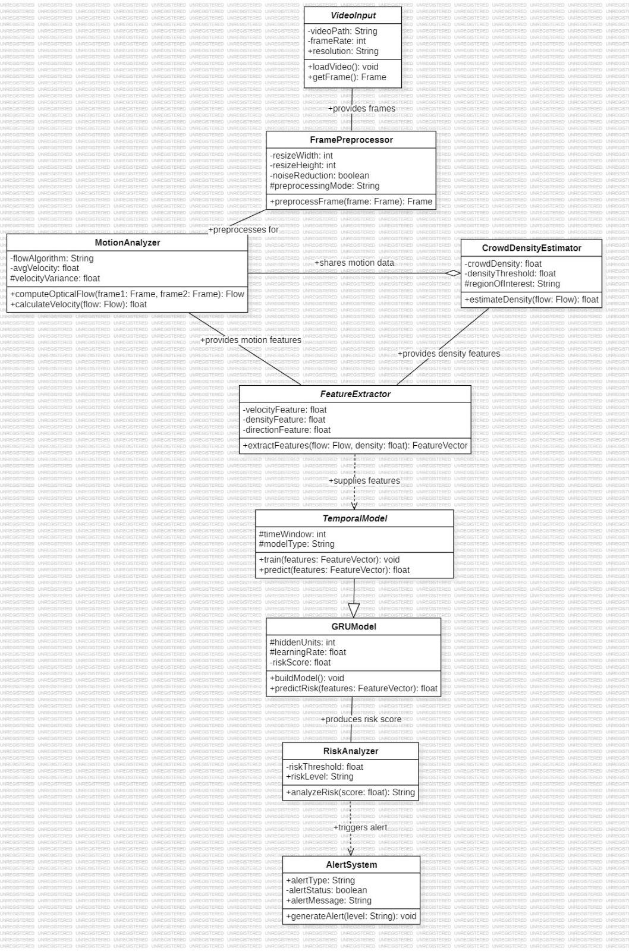
Class Diagram

Real-Time Crowd Dynamics Analysis for  Preemptive Stampede Prediction using  ConvLSTM-Based Video Prediction | Version : 1.1
Software Requirements Specification | Date : Janurary 20,2026

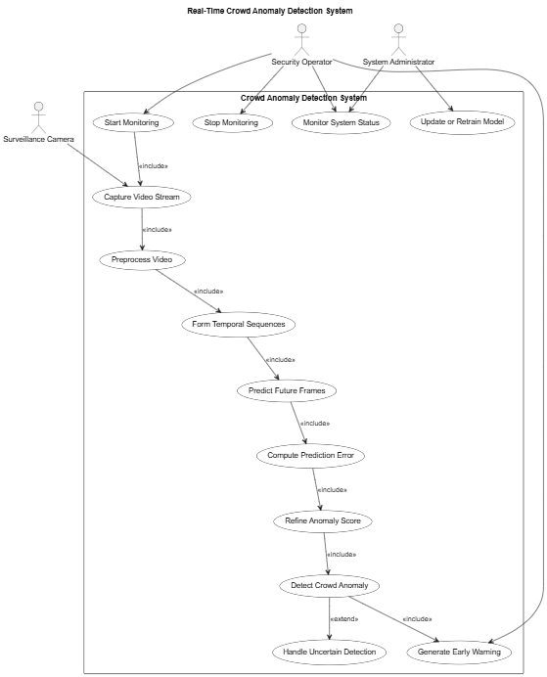

Use Case Diagram

Real-Time Crowd Dynamics Analysis for  Preemptive Stampede Prediction using  ConvLSTM-Based Video Prediction | Version : 1.1
Software Requirements Specification | Date : Janurary 20,2026

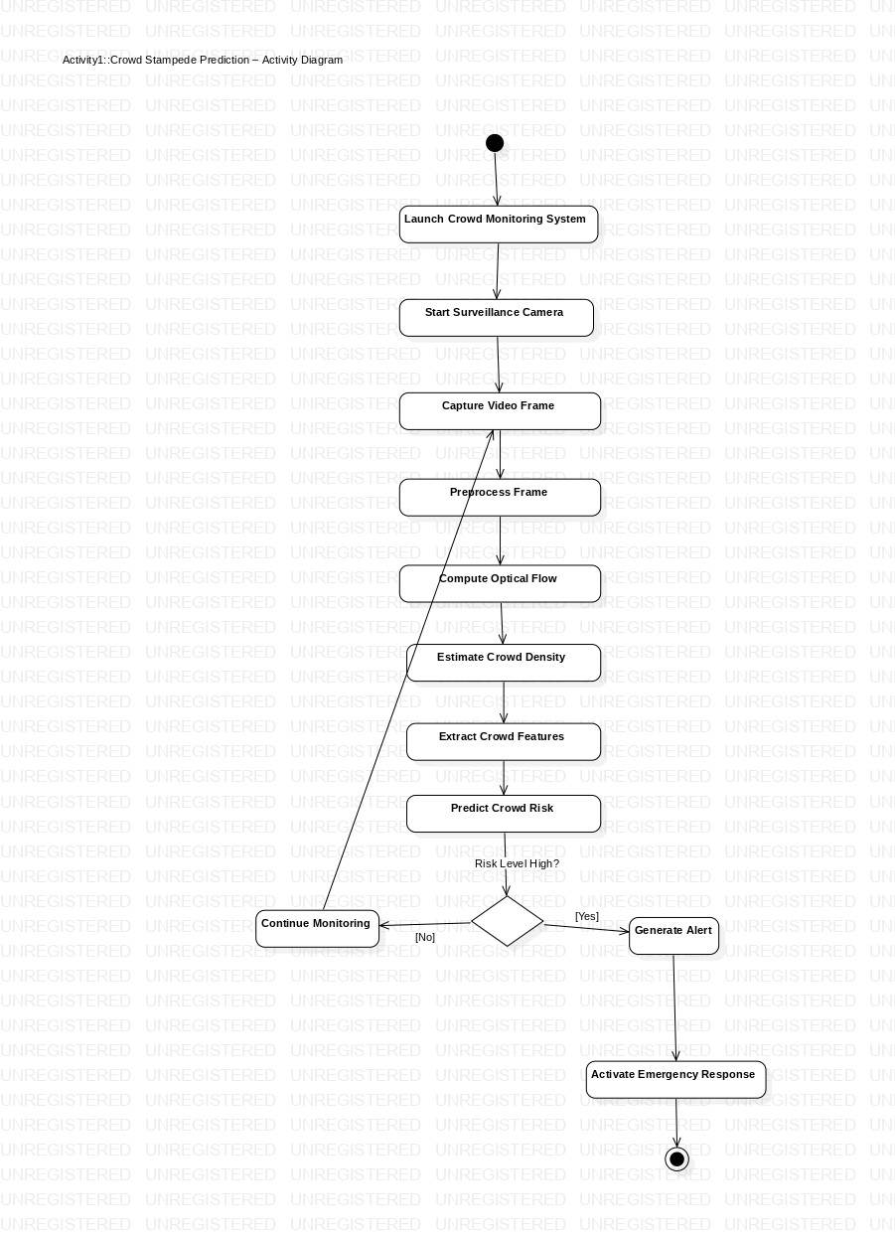
Activity Diagram

Real-Time Crowd Dynamics Analysis for  Preemptive Stampede Prediction using  ConvLSTM-Based Video Prediction | Version : 1.1
Software Requirements Specification | Date : Janurary 20,2026

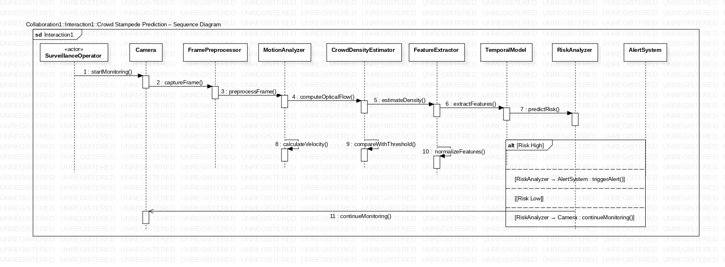
Sequence_Diagram
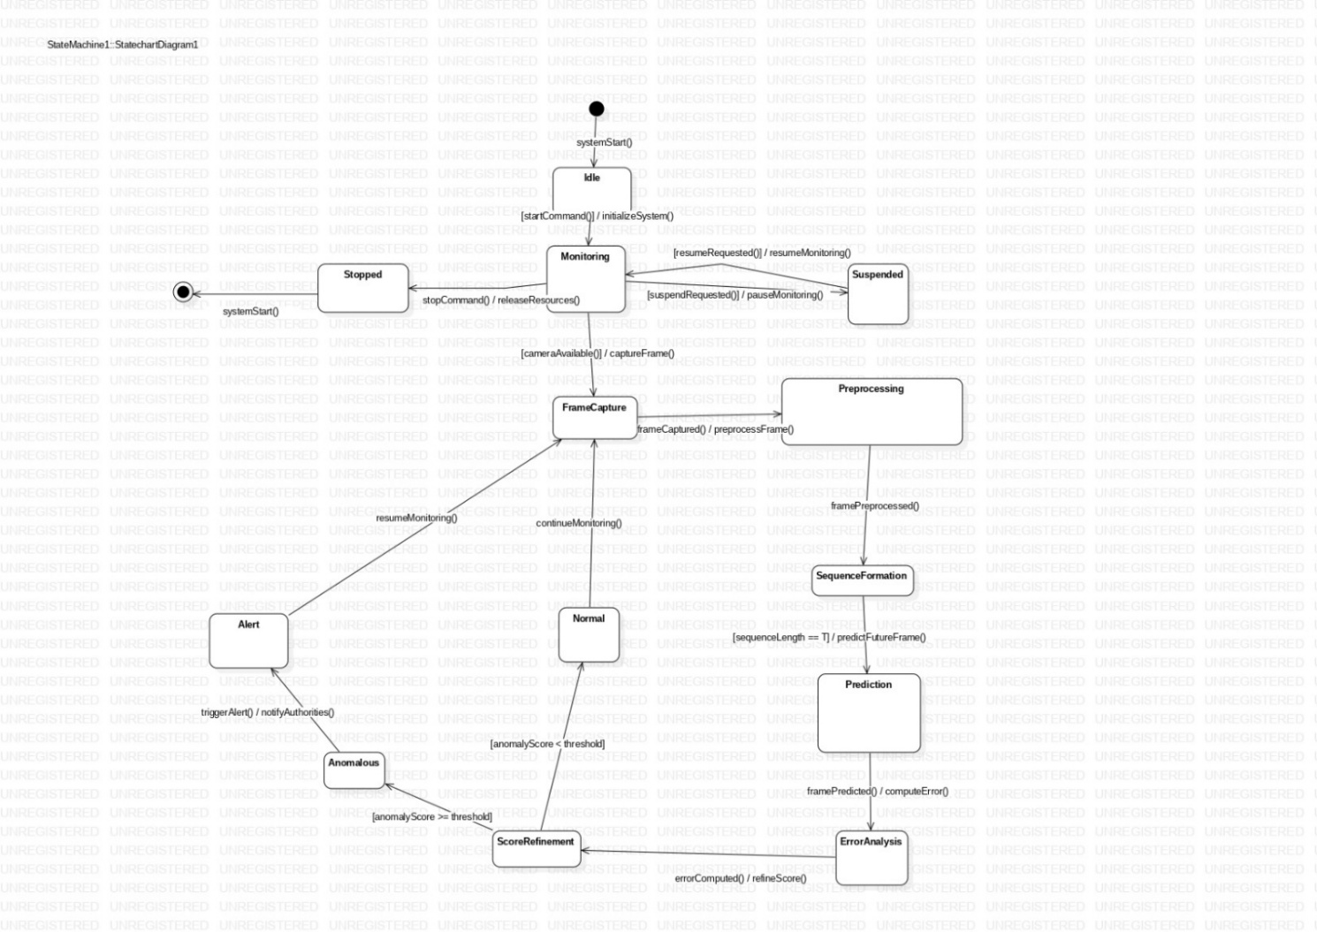State Transition Diagram

Real-Time Crowd Dynamics Analysis for  Preemptive Stampede Prediction using  ConvLSTM-Based Video Prediction | Version : 1.1
Software Requirements Specification | Date : Janurary 20,2026

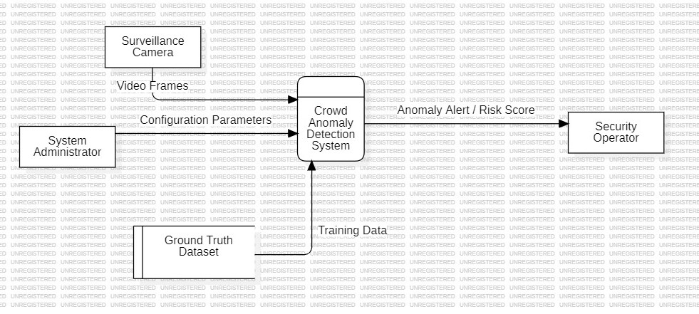
Data flow diagram[Level -0]

Real-Time Crowd Dynamics Analysis for  Preemptive Stampede Prediction using  ConvLSTM-Based Video Prediction | Version : 1.1
Software Requirements Specification | Date : Janurary 20,2026

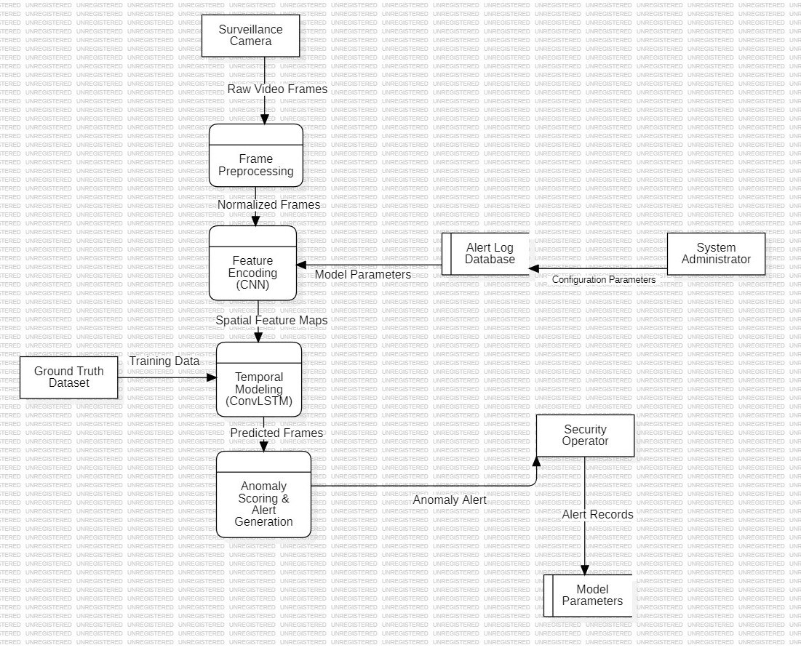

Data flow diagram [Level -1]

3.9.1 Hardware Interfaces
The system shall interface with the device’s hardware components, including the camera for capturing images of currency notes and the audio output hardware for delivering voice-based feedback to the user. The system relies on standard hardware interfaces provided by the device and does not require any additional external hardware components.

3.9.2 Software Interfaces
The system shall interface with the underlying operating system to access the camera, audio output, and storage components. Standard application programming interfaces (APIs) provided by the operating system shall be used to ensure secure and controlled access to these components. The system may also interface with third-party libraries for currency detection and text-to-speech functionality.

3.9.3 Communication Interfaces

Real-Time Crowd Dynamics Analysis for  Preemptive Stampede Prediction using  ConvLSTM-Based Video Prediction | Version : 1.1
Software Requirements Specification | Date : Janurary 20,2026

The system shall operate primarily as a standalone application and does not require continuous network connectivity. When

Internet connectivity is available, it may be utilized for software updates, model enhancements, and system maintenance purposes.
3.10 Licensing Requirements
The usage of the Online Library System shall be restricted exclusively to the University of Houston–Clear Lake Library, which has purchased the system from Library InfoSys and has entered into a valid maintenance and support contract.
3.11 Legal, Copyright, and Other Notices
The Online Library System is a registered trademark of Library InfoSys. Unauthorized use, reproduction, or distribution of the system or its trademarked components is prohibited without prior written consent from Library InfoSys.
3.12 Applicable Standards
The system documentation and development process shall adhere to the ISO/IEC 6592 guidelines for the documentation of computer-based application systems.

Supporting Information
The use-case storyboards or the user-interface prototypes are not available. The appendices are not to be considered as part of the requirements.

vuvuvuvuv

